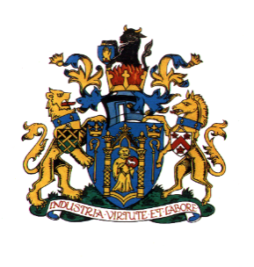
YEOVIL TOWN COUNCIL

CONTRIBUTION TOWARDS THE OCTAGON THEATRE PROJECT
Each member of your household who is on the electoral register can take part in the consultation.
- Are you in FAVOUR of Yeovil Town Council going ahead with the contribution of £3,964,500 (including Stamp Duty) towards the Octagon Theatre Project resulting in borrowing of £3,325,000?
YES NO (please tick appropriate box)
- Are you in FAVOUR of Yeovil Town Council going ahead with the contribution of £3,964,500 (including Stamp Duty) towards the Octagon Theatre Project resulting in borrowing of £3,325,000, if it includes a Council tax precept increase of 3.3% (equivalent to £110,062.69) for the purpose of the loan repayments?
YES NO (please tick appropriate box)
Name

Address

Signed

Date

Please send your response to Yeovil Town Council at the address below by: 21st September 2025
Yeovil Town Council
Town House

19 Union Street
YEOVIL
BA20 1PQ
e-mail : octagontheatre@yeovil.gov.uk

You may return the questionnaire to any of the following locations:
- Westlands Entertainment Venue (Box Office)
- Yeovil Country Park (Ninesprings Café)
- Yeovil Recreation Centre (The Rec Café)
Alternatively, why not complete the online form by scanning the QR code?
Thank you for taking the time to have your say on this important project.

